Week 2 lab

**Exercise 2:**

1. [www.google.co.uk](http://www.google.co.uk/) reachable

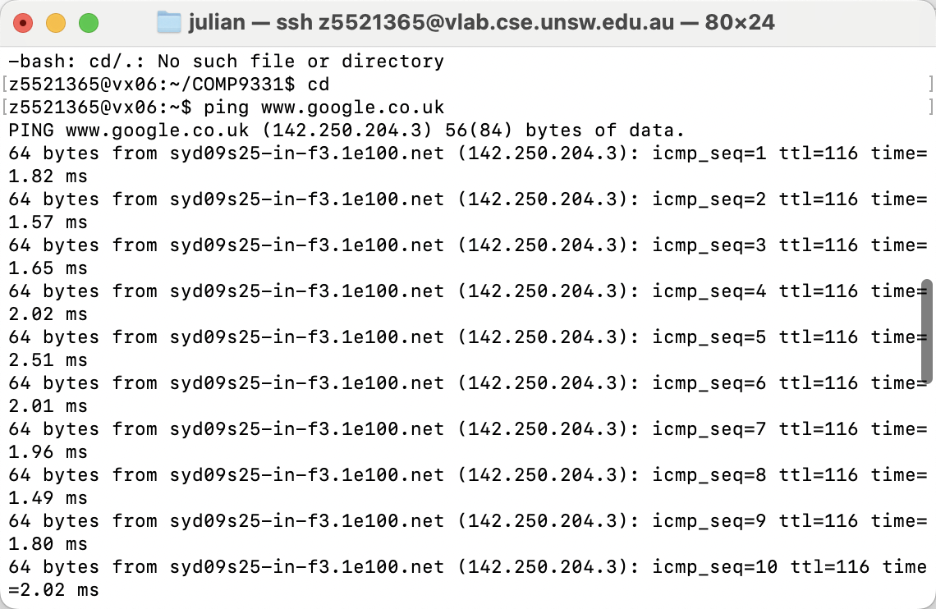

2. [www.columbia.edu](http://www.columbia.edu/)

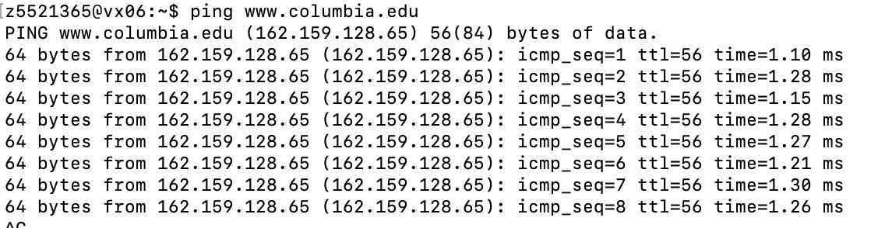

1. [www.wikipedia.org](http://www.wikipedia.org)

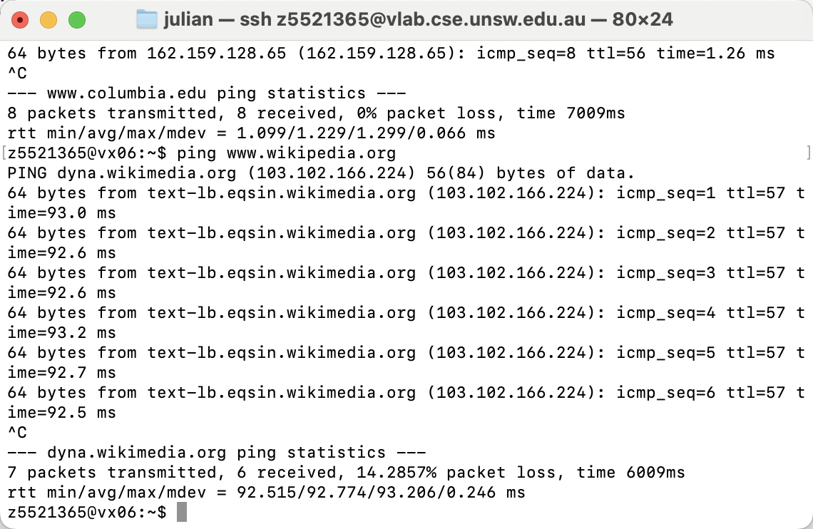

4 . ec.ho

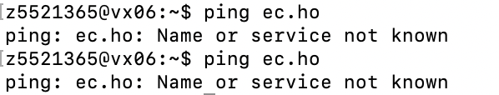

5.

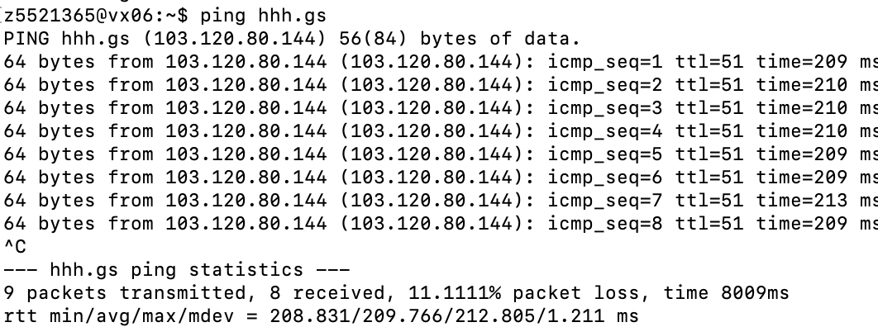

6. unreachable defence.gov.au

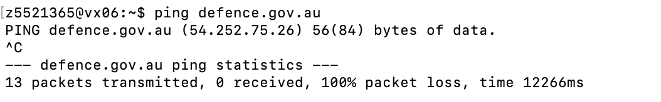

7. [yes.no](http://yes.no/)

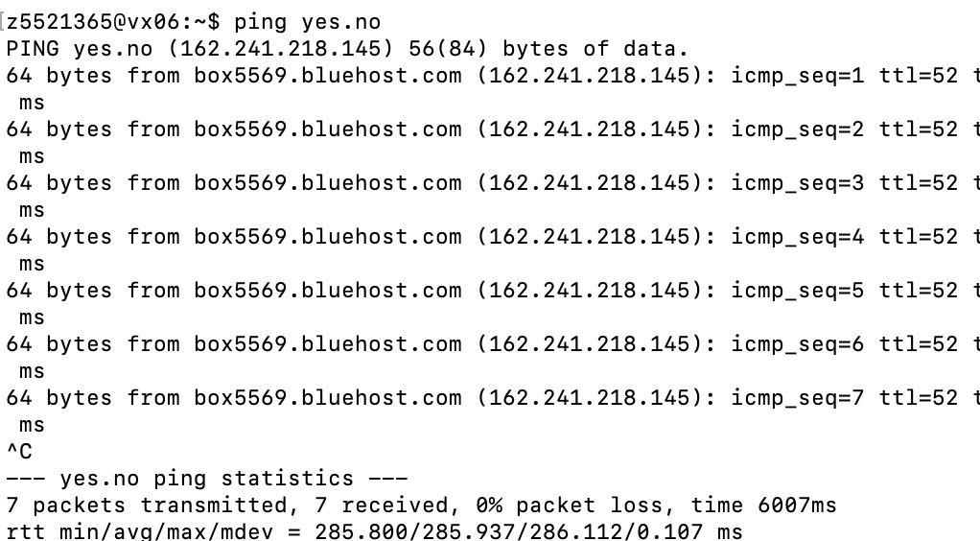

8. [one.one.one.one](http://one.one.one.one/)

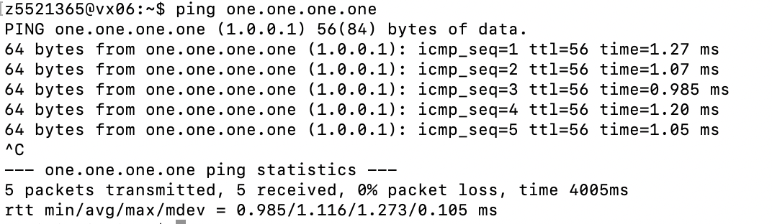

9. [theguardian.com](http://theguardian.com/)

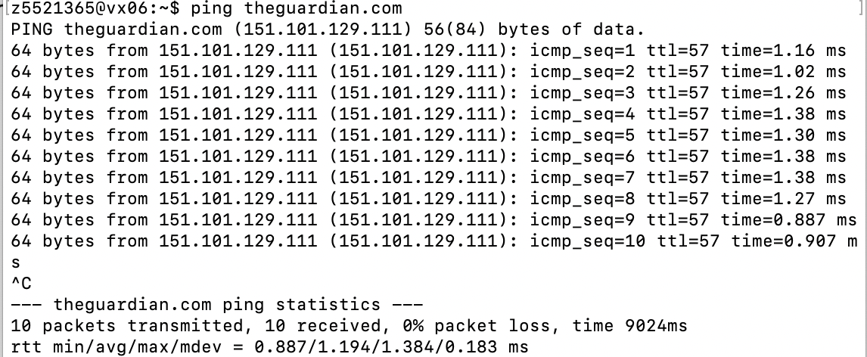

10. [xn--i-7iq.ws](http://xn--i-7iq.ws/)

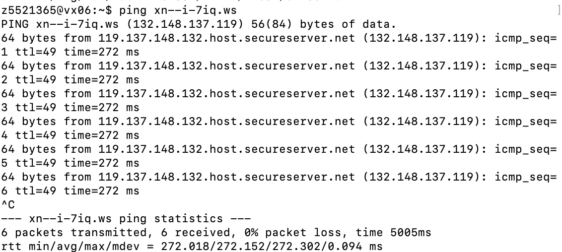

**Exercise 3:**

**1.**

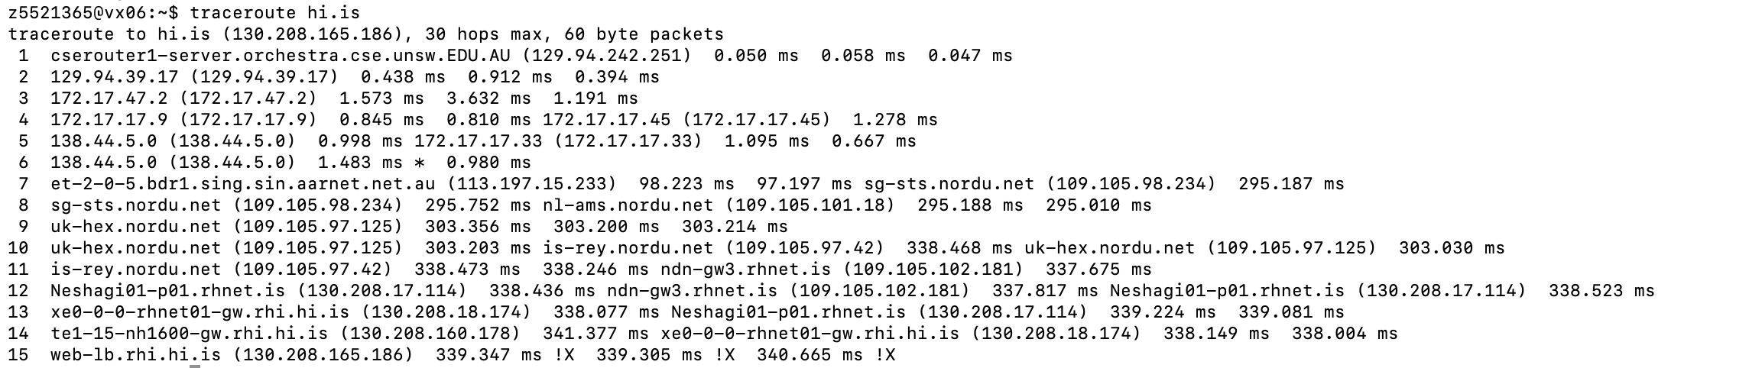

1. It totally has 15 routers, there are 6 routers which belong UNSW network system.
2. 113.197.15.233 is the first IP which outside Australia.
3. 109.105.97.125

2.

[arizona.edu](http://arizona.edu)

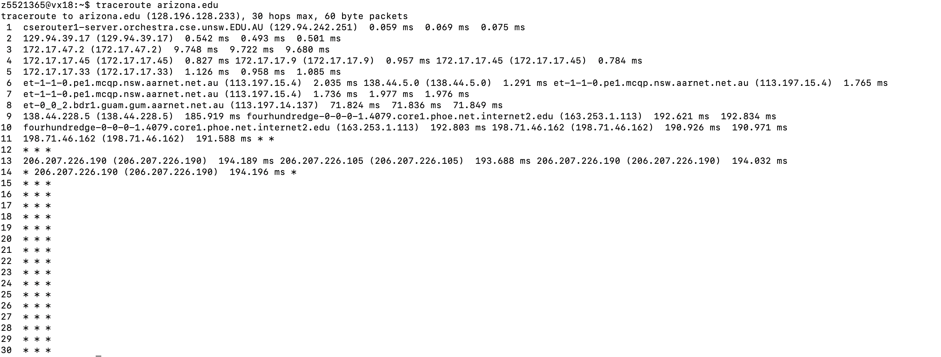

Ufrgs.br

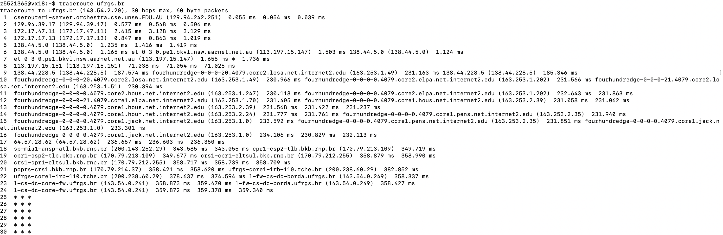

Uhi.ac.uk

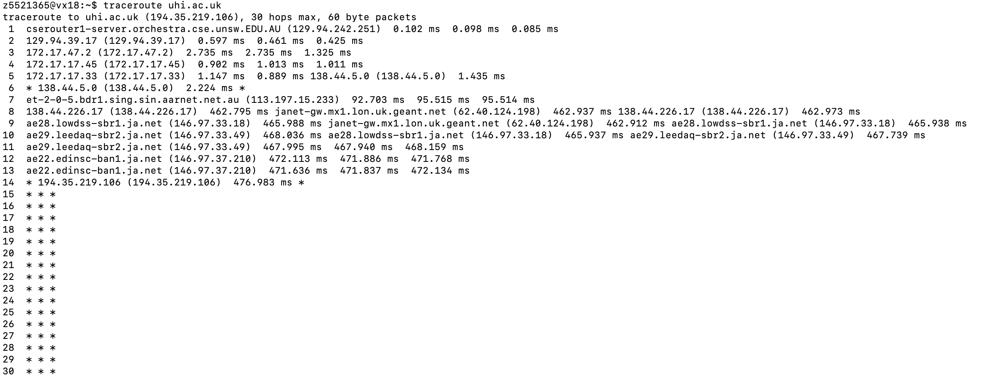

1. 138.44.5.0 is the last router which they all have.

**Detail:**

NetRange: 138.44.0.0 - 138.44.255.255

CIDR: 138.44.0.0/16

NetName: APNIC-ERX-138-44-0-0

NetHandle: NET-138-44-0-0-1

Parent: NET138 (NET-138-0-0-0-0)

NetType: Early Registrations, Transferred to APNIC

OriginAS:

Organization: Asia Pacific Network Information Centre (APNIC)

RegDate: 2003-12-11

Updated: 2009-10-08

Comment: This IP address range is not registered in the ARIN database.

Comment: This range was transferred to the APNIC Whois Database as

Comment: part of the ERX (Early Registration Transfer) project.

Comment: For details, refer to the APNIC Whois Database via

Comment: WHOIS.APNIC.NET or http://wq.apnic.net/apnic-bin/whois.pl

Comment:

Comment: ** IMPORTANT NOTE: APNIC is the Regional Internet Registry

Comment: for the Asia Pacific region. APNIC does not operate networks

Comment: using this IP address range and is not able to investigate

Comment: spam or abuse reports relating to these addresses. For more

Comment: help, refer to http://www.apnic.net/apnic-info/whois_search2/abuse-and-spamming

Ref: https://rdap.arin.net/registry/ip/138.44.0.0

ResourceLink: http://wq.apnic.net/whois-search/static/search.html

ResourceLink: whois.apnic.net

(2)

Compare with three locations ，No, it is not proportional to the physical distance

13 hops

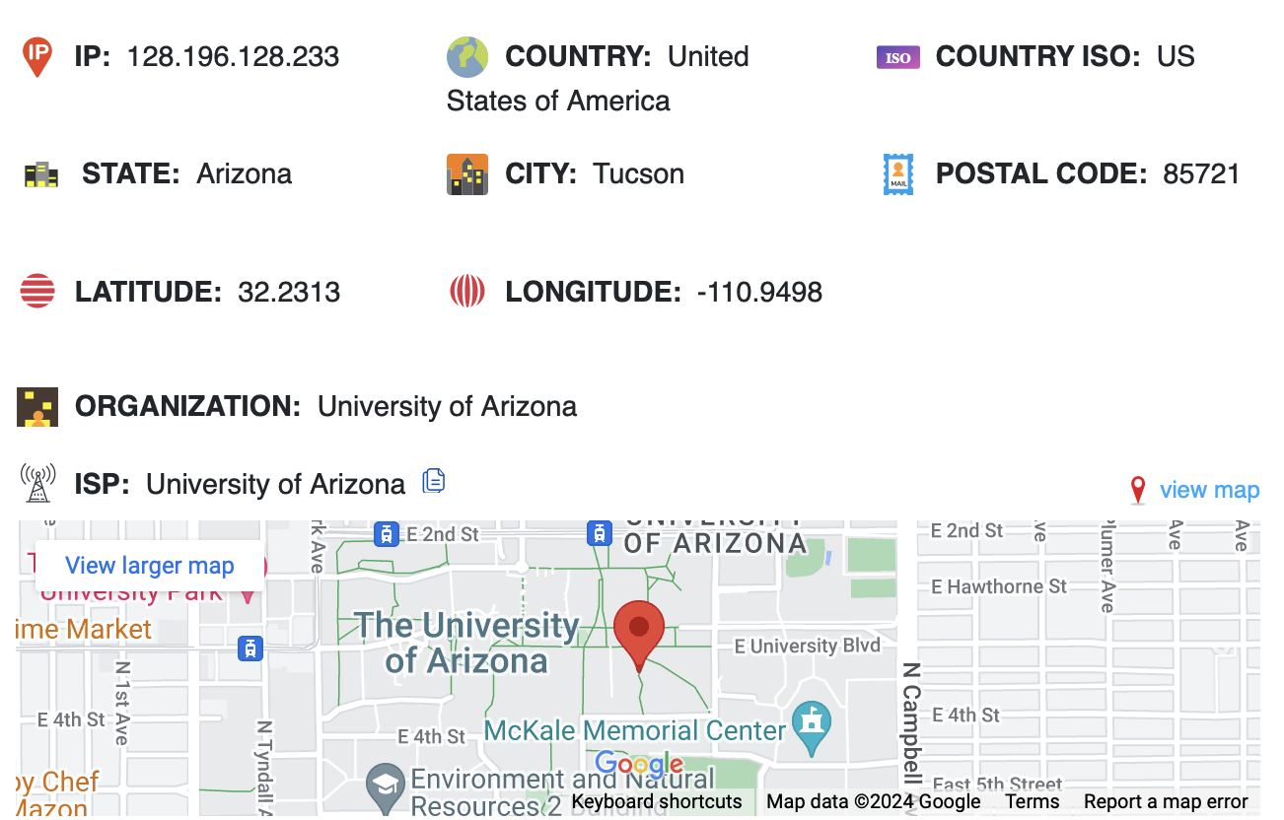

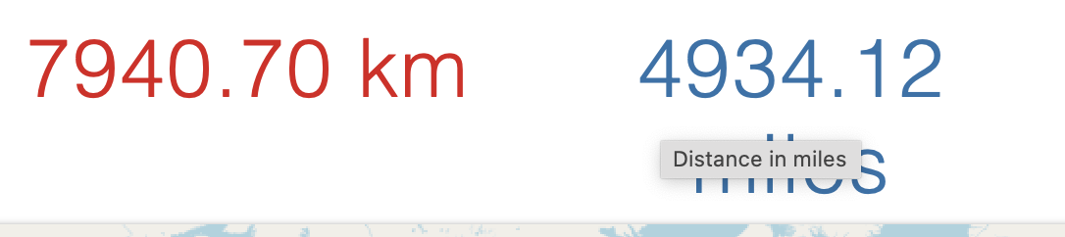

24 hops

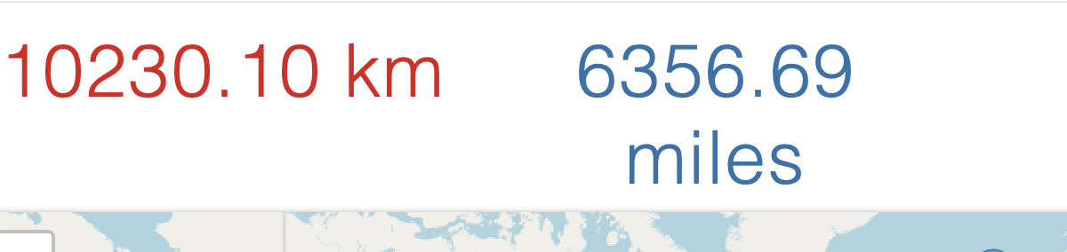

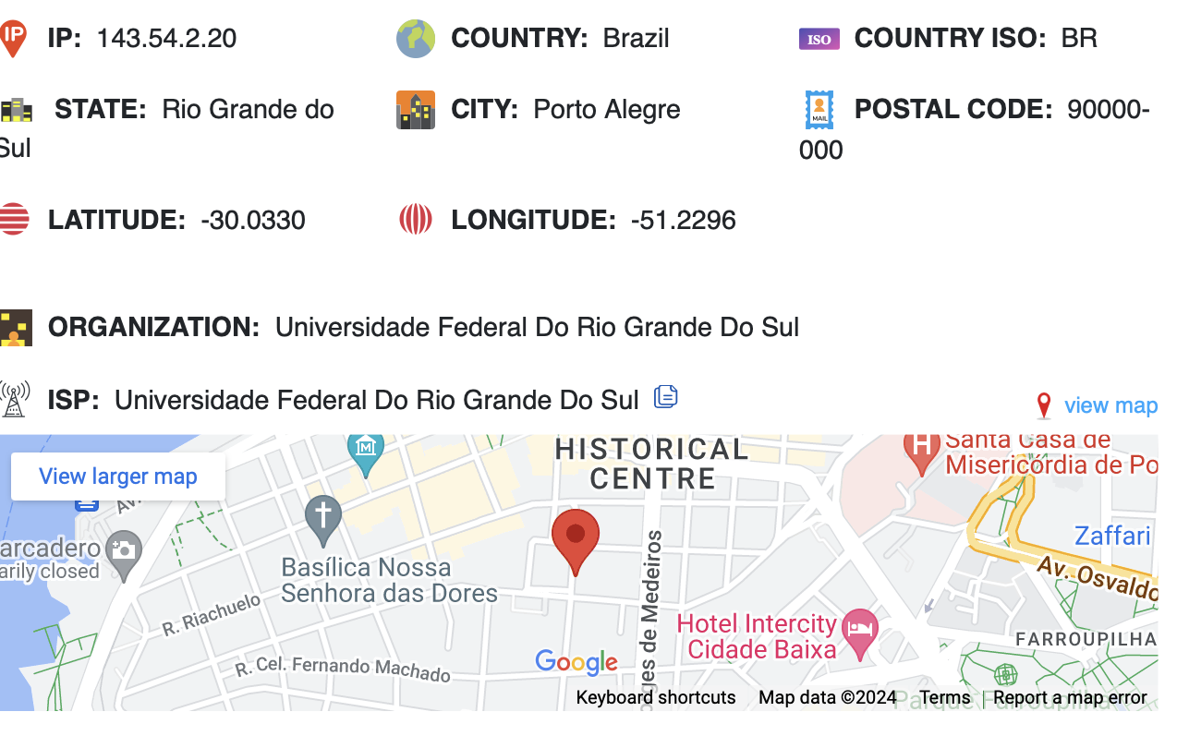

14hops

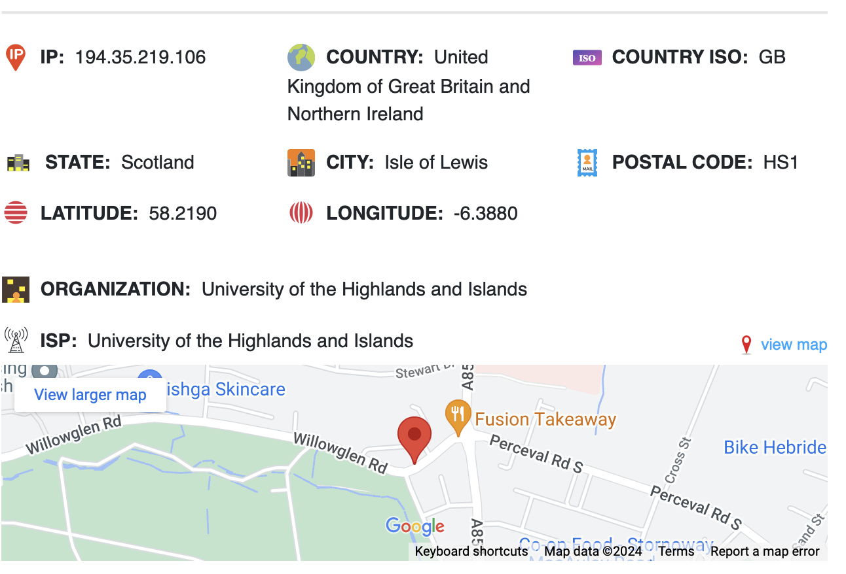

3.

(1)

My machine Ip in cse is: 129.94.242.93

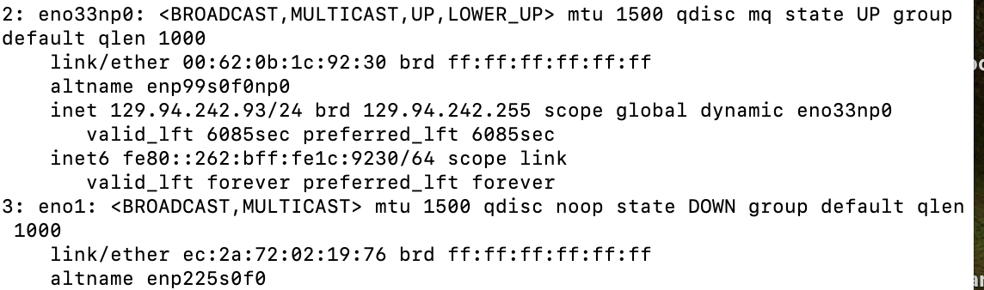

Forward traceroute path

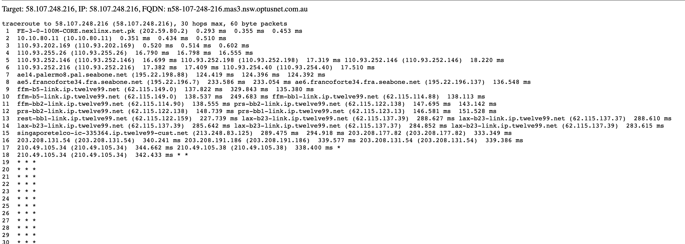

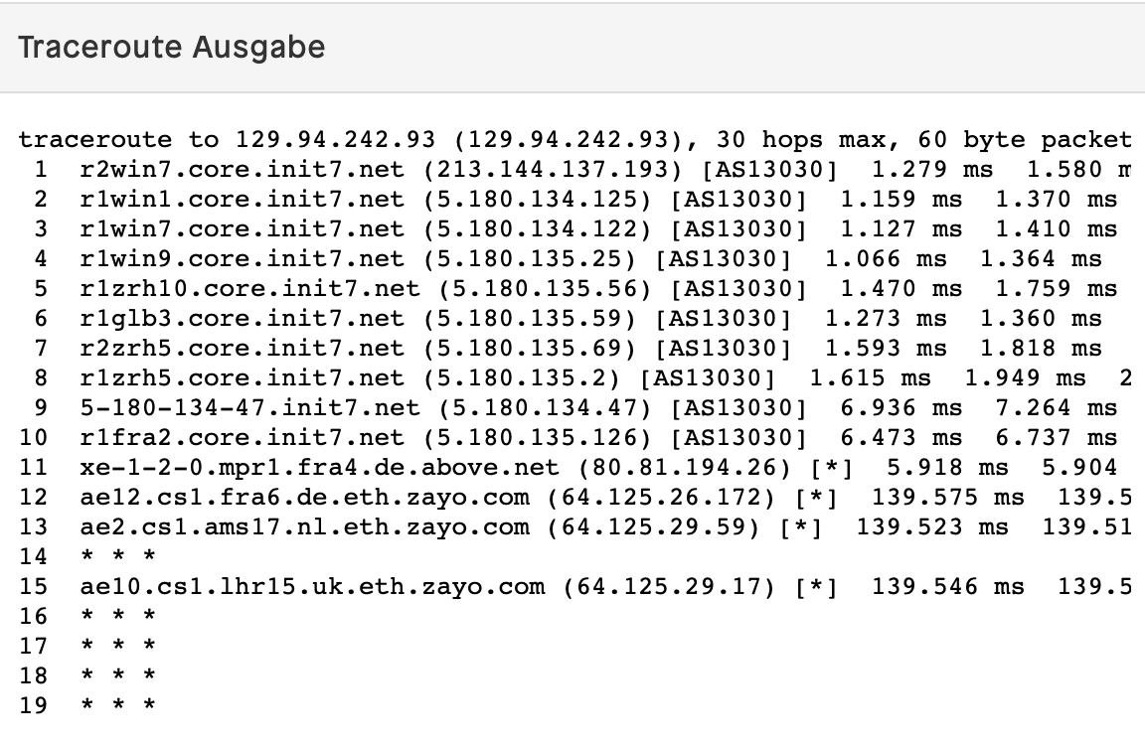

Reverse path

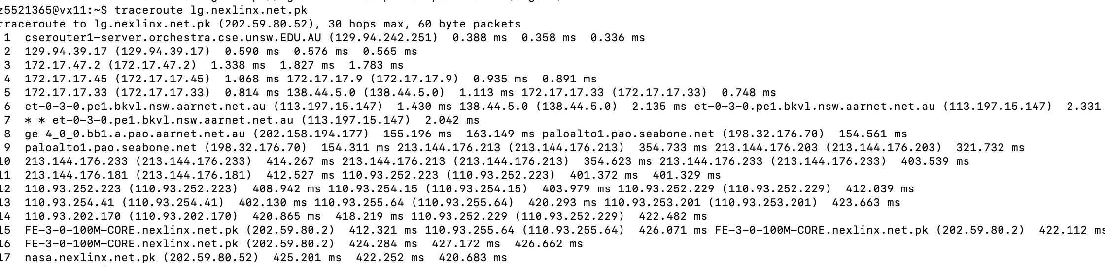

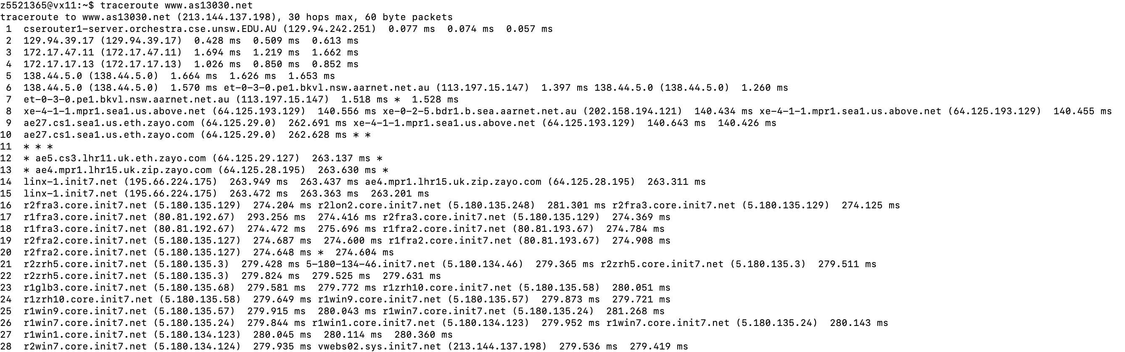

<http://lg.nexlinx.net.pk/> : 202.59.80.52

[www.as13030.net/traceroute.php](http://www.as13030.net/traceroute.php): 213.144.137.198

(2)

It is different, but some of router are likely.

(3) If there are the same routers in the path, they may have different IP addresses. This is because the same router will use different IP addresses on different interfaces. In addition, the network paths may be asymmetric, and the forward and reverse paths may not be exactly the same.

**Exercise 4:**

**1.**

**Our current cse machine Ip:** 129.94.242.153

For one of uq.edu.au-*, we know the Ip of domain is 130.102.184.3

Physical distance:

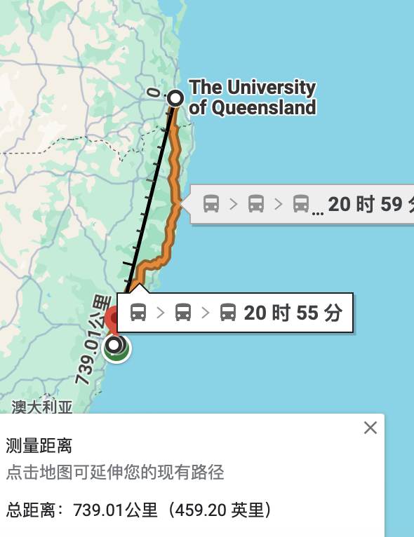

Shortest possible time:

T= 739.01km/3*10**8= 0.00246336667s

From unsw to The Federal University of Rio Grande do Sul, Porto Alegre,Brazil)

For one of ufrgs.br-p* , we know ip is 143.54.2.20

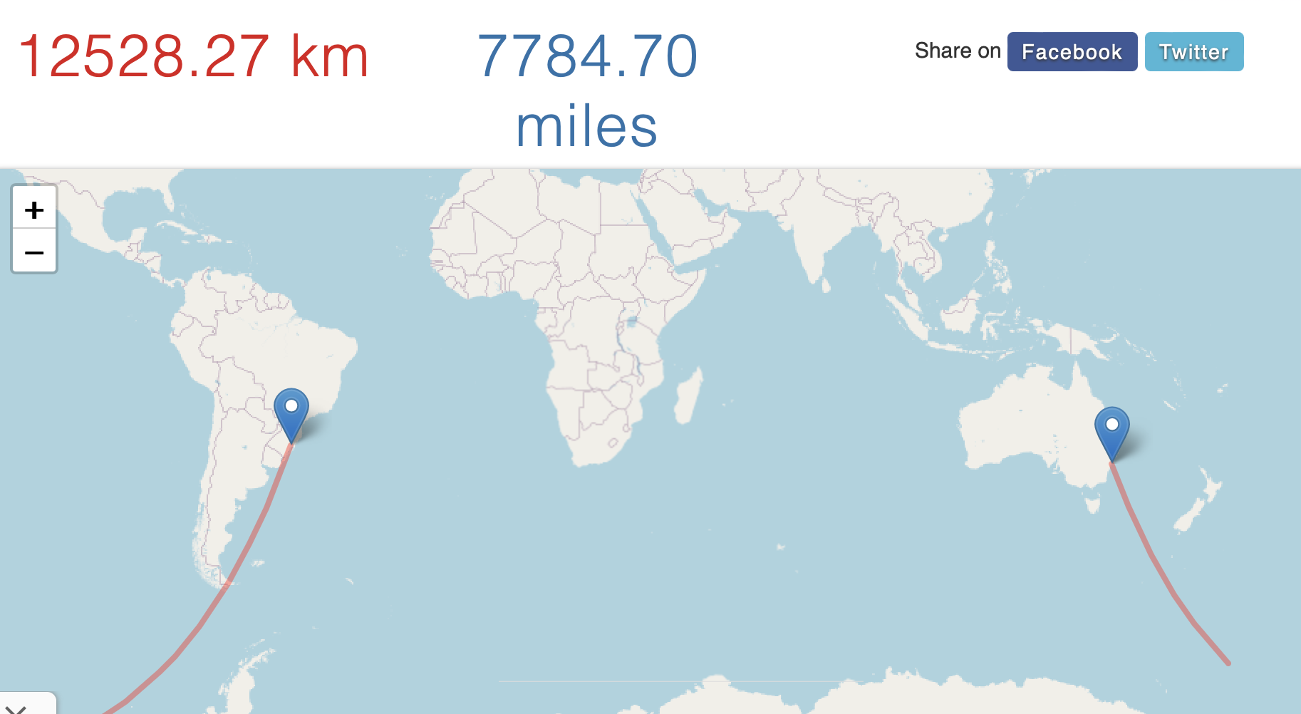

T = 12528.27km/3*10**8=41.7609ms

For one of **ku.dk-p**\*, we know Ip is 130.226.237.173

From unsw to university of Copenhagen - Copenhagen, Denmark

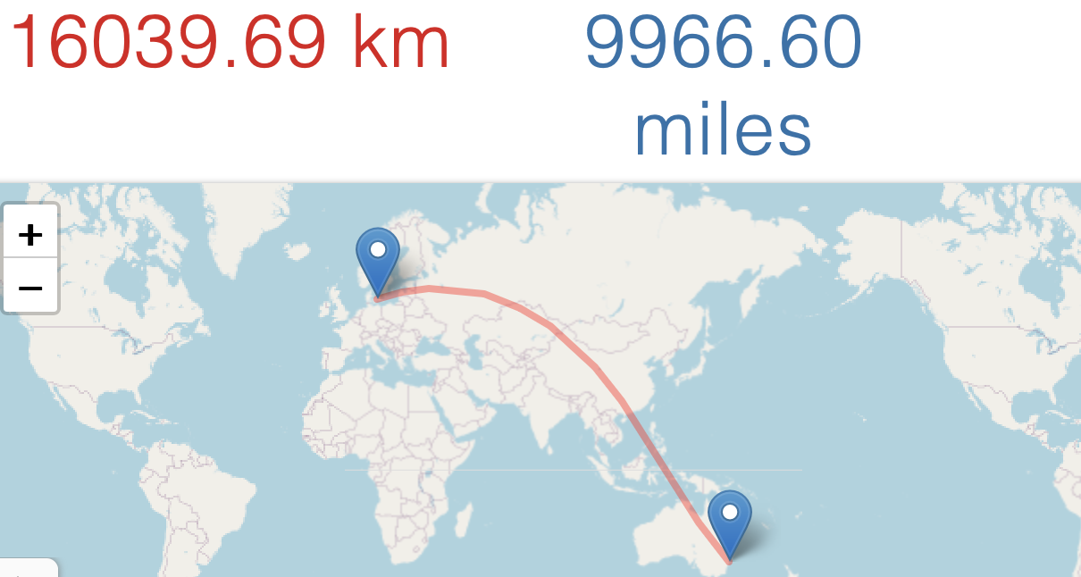

T = 16039.69km/3*10**8≈0.053466s

**2.**

**UQ:**

**Formula: Ratio= RRT/2*T**

**RRT: 16.674 ms**

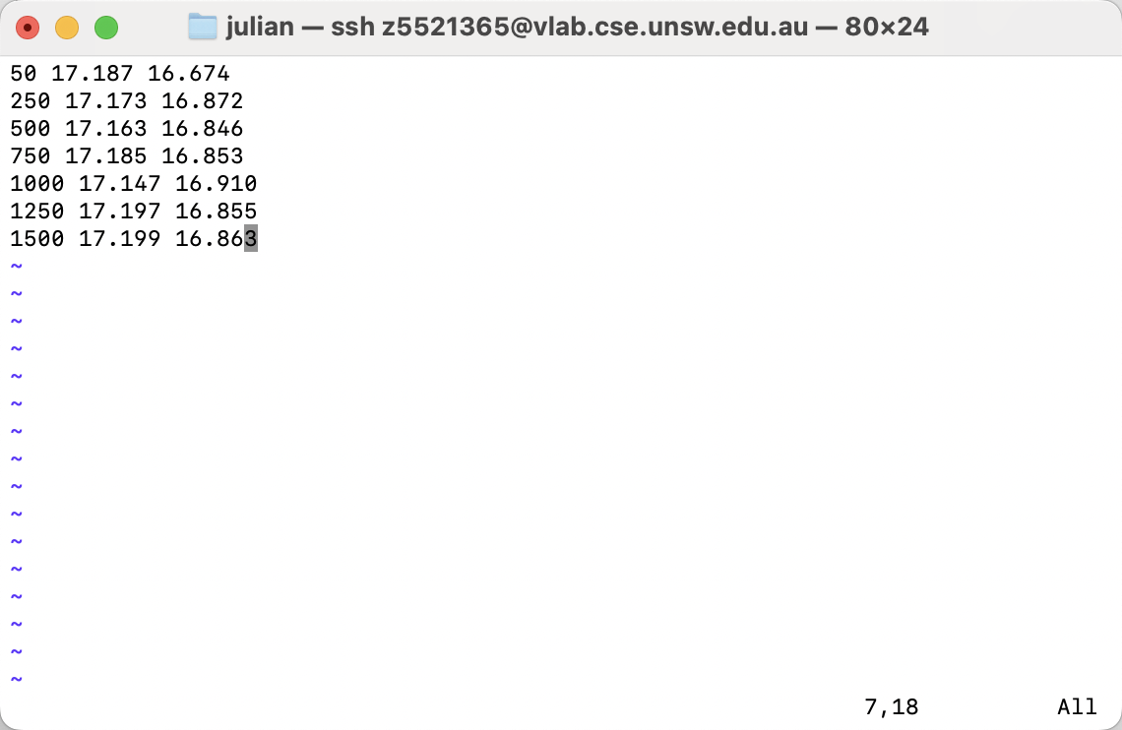

**Distance:** 1676.76km

**Ratio =0.016674s/(2*0.00246336667s)=**3.38

**RRT:356.390ms**

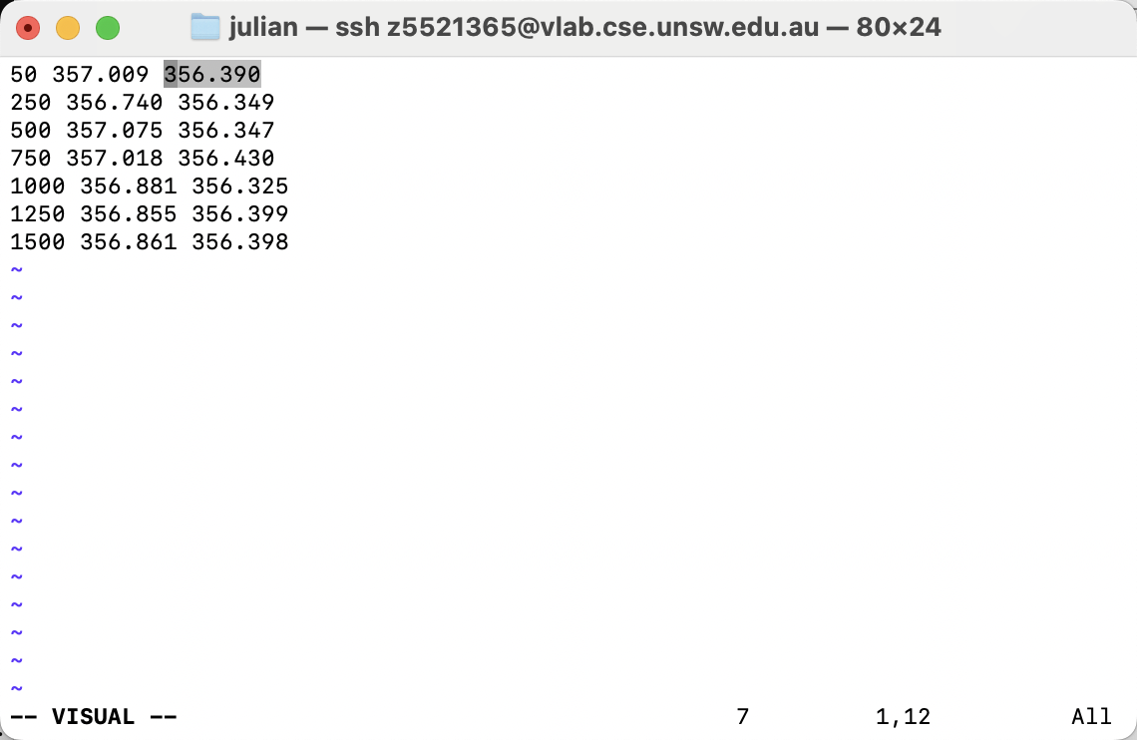

**Distance:** 12528.27km=12528270m

**Ratio =0.356390s/(2*0.0417609s)=4.266**

**RRT:321.324ms**

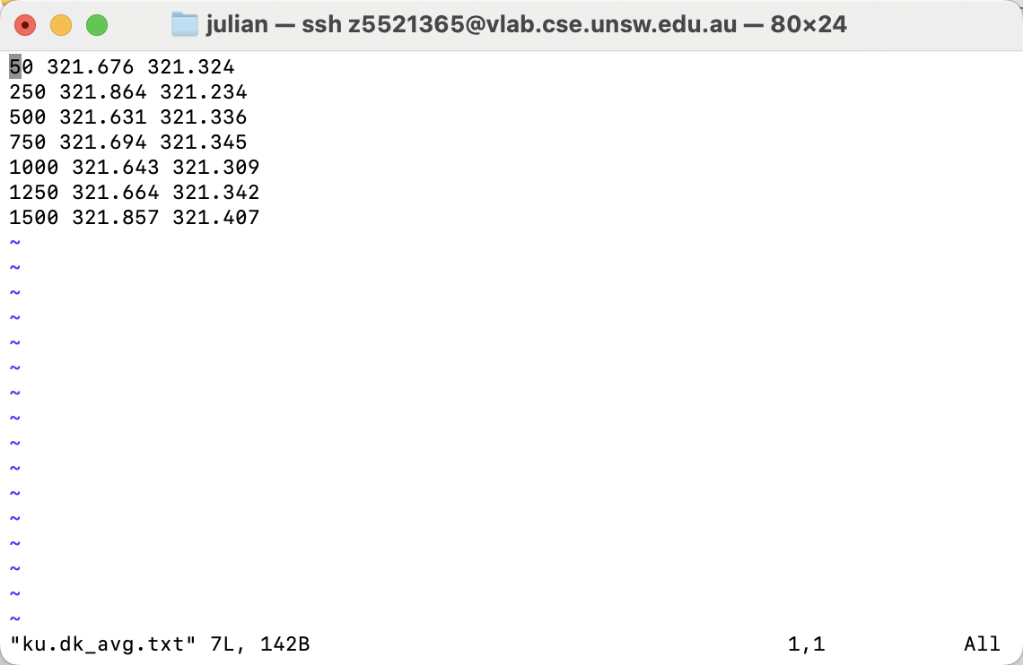

**Distance: 16039.69km**

**Ratio =0.321324/(2*0.053466s)=** **3.000**

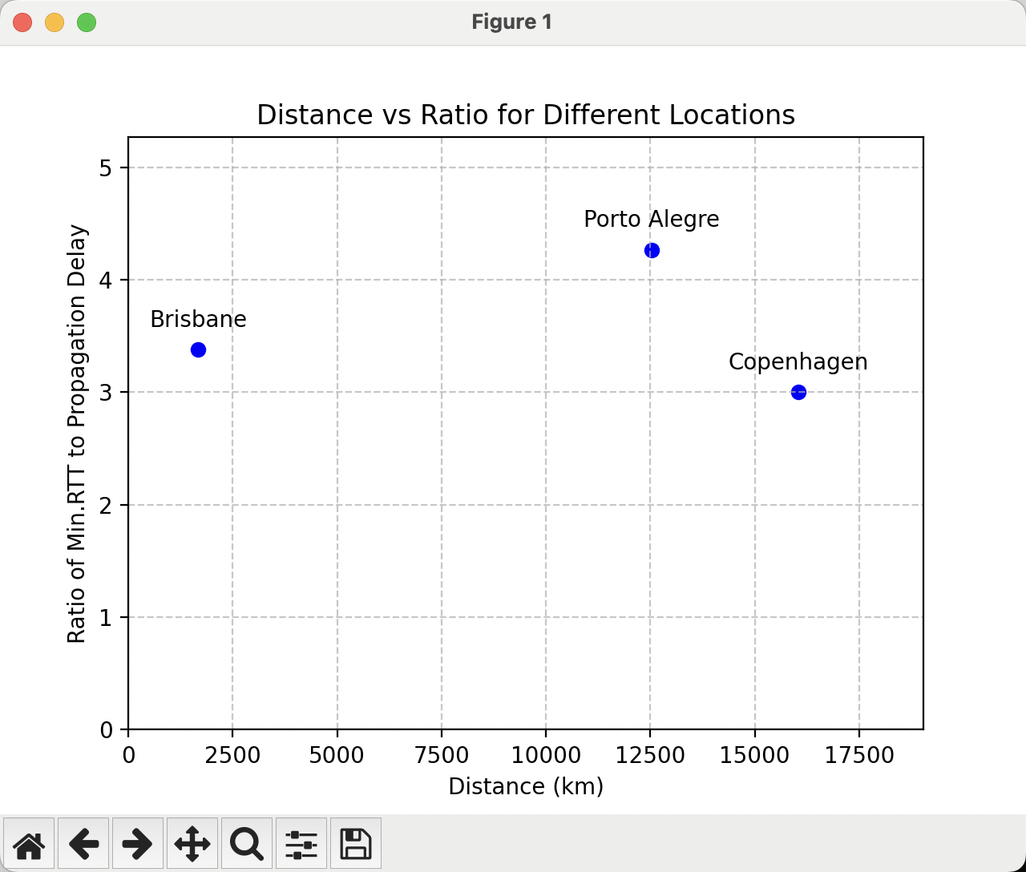

3.

Latency which also effect by

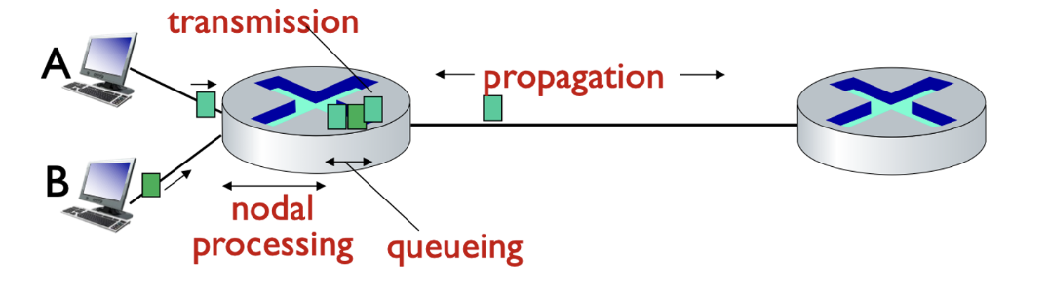

So the delay will increase in propagation time

In addition, ping testing also include other extra delay, that will be made propagation time over 2 times

4.

The delay usually varies over time. Latency in a network is affected by many factors, including network congestion, router load, and packet loss rates. Changes in these factors can cause delays to fluctuate over time.

5.

Transmission delay , nodal processing and queueing delay all depend on size of packets